CAPSTONE PROJECT REPORT
DEPARTMENT OF COMPUTER APPLICATIONS

NEHRU COLLEGE OF ENGINEERING AND RESEARCH CENTRE
AN AUTONOMOUS INSTITUTION AFFILIATED TO APJ ABDUL KALAM TECHNOLOGICAL UNIVERSITY, KERALA

(NAAC Re-Accredited with “A” Grade)
An ISO Certified Institution,
Pampady, Thiruvilwamala, Thrissur-680588

CHATOZZ

Real Time Communication Platform Using OOPS Concept

APRIL 2026


CHATOZZ
Real Time Communication Platform Using OOPS Concept.

Presented by
Gupthan Vishnu Prasad
Farsheena P H
Jifana
Athira K U
Ambili Chandran
Amal Chandran
Ajal Krishna S
V Vishnu
Jeffin Johnson Pinhero
Anupama K Kumar

INTRODUCTION

Communication systems have evolved significantly with the advancement of technology. Chat applications play a crucial role in modern communication by enabling instant messaging over the internet.
The ChatoZZ application is designed as a simple messaging platform where users can communicate efficiently. It uses internet connectivity (Wi-Fi or mobile data) to exchange messages in real-time.
This project focuses on applying Object-Oriented Programming concepts to build a scalable and maintainable chat system.

ABSTRACT

The Chat Application (ChatoZZ) is an Object-Oriented Programming (OOP)-based software system designed to enable real-time communication between users. The system allows users to send and receive messages through a simple and user-friendly interface. It utilizes networking concepts along with OOP principles to ensure modularity, scalability, and maintainability.
The application supports features like user login, message exchange, and real-time communication using sockets. The project demonstrates the practical implementation of OOP concepts such as encapsulation, inheritance, polymorphism, and abstraction

OBJECTIVES

- To develop a real-time chat application using OOP principles
- To understand client-server architecture
- To implement socket programming for communication
- To design a user-friendly interface
- To ensure modular and reusable code structure
- To enhance teamwork and project development skills

OOPS Concept

3.1 Class
A class is a blueprint for creating objects.
Example:
User class
Message class ChatRoom class

3.2 Object
Objects are instances of classes.
Example:
User1
User2

3.3 Encapsulation
Data and methods are combined into a single unit.
Example: User details and methods are kept inside the User class.

3.4 Inheritance
One class inherits properties from another class.
Example: Admin user inherits from User class.
3.5 Polymorphism
Same method can perform different tasks.

SYSTEM REQUIREMENTS
- Hardware Requirements
- Computer / Laptop
- Minimum 4GB RAM
- Software Requirements
- Java / Python / C++
- IDE (Eclipse / VS Code)

SYSTEM DESIGN
- Modules
- User Login Module
- Send Message Module
- Receive Message Module
- Chat Display Module

ALGORITHM
- Start the application
- User logs in
- Enter message
- Send message
- Display message to receiver
- Receiver replies
- End

SCREENSHOT SAMPLES
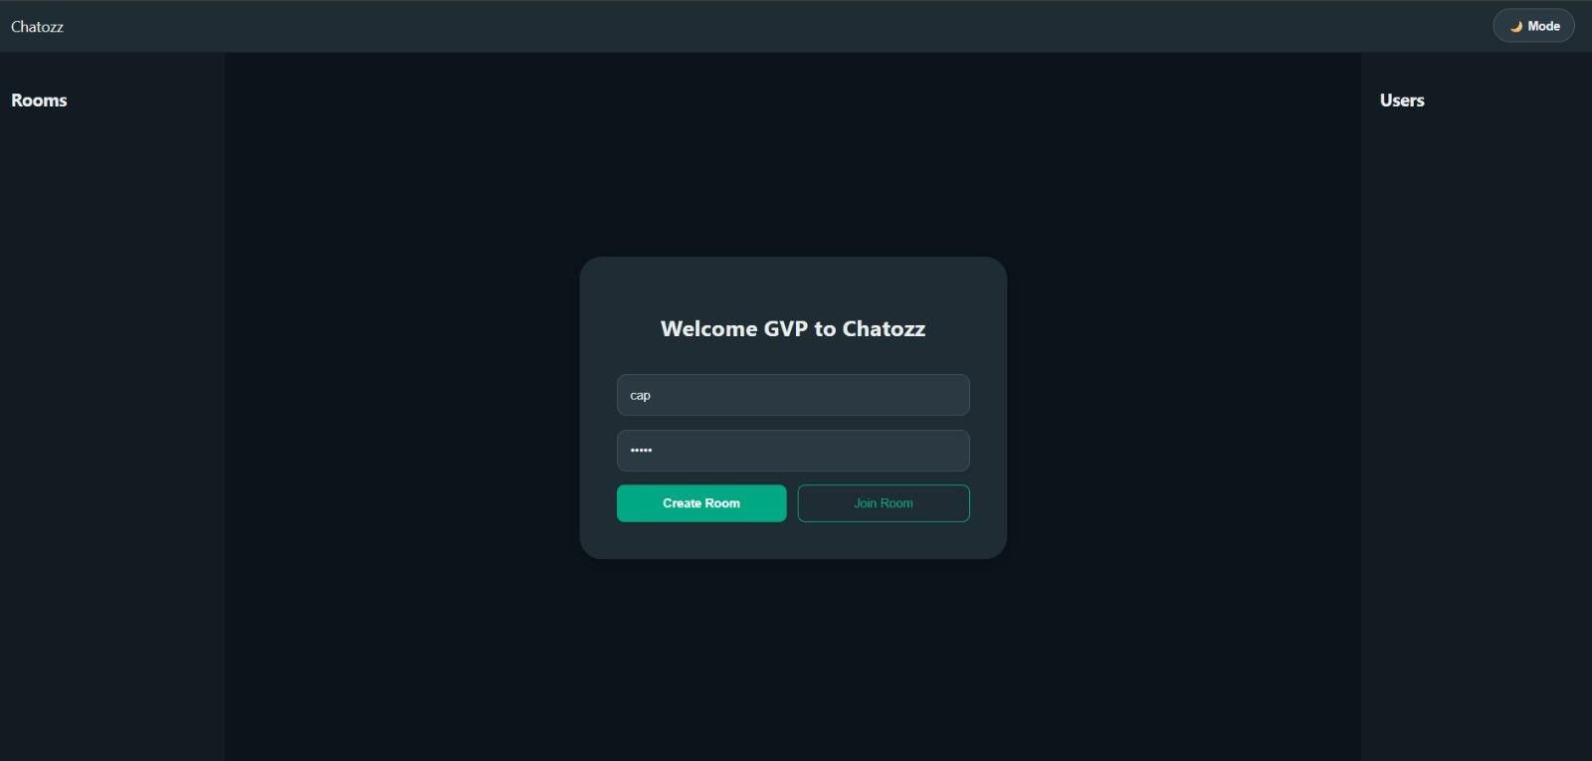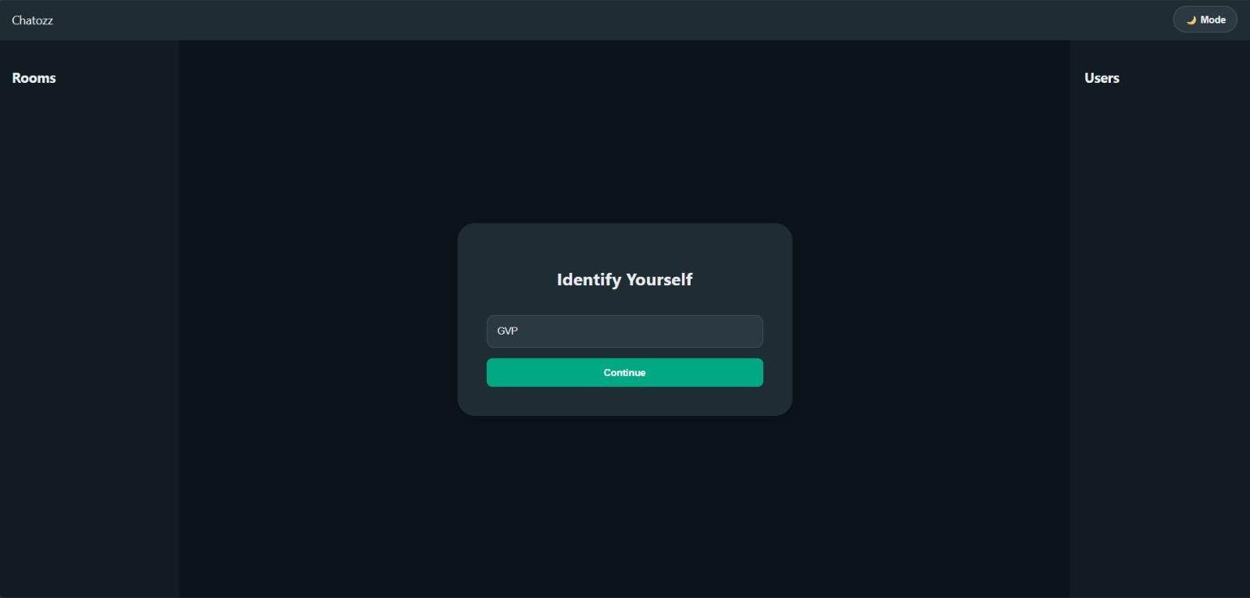



FUTURE ENHANCEMENT

- Add group chat
- Add file sharing
- Add voice chat
- Database storage

CONCLUSION

The Chat Application project successfully demonstrates the use of Object-Oriented Programming concepts. It helps in understanding how classes, objects, inheritance, and encapsulation are used in real applications.

